**WEEK - 2**

**JUnit Basic Testing**

**Mandatory**

**Exercise 1: Setting Up JUnit**

package com.example;

import org.junit.Test;

import static org.junit.Assert.*;

public class CalculatorTest {

@Test

public void testAddition() {

int expected = 5;

int actual = 2 + 3;

assertEquals(expected, actual);

}

}

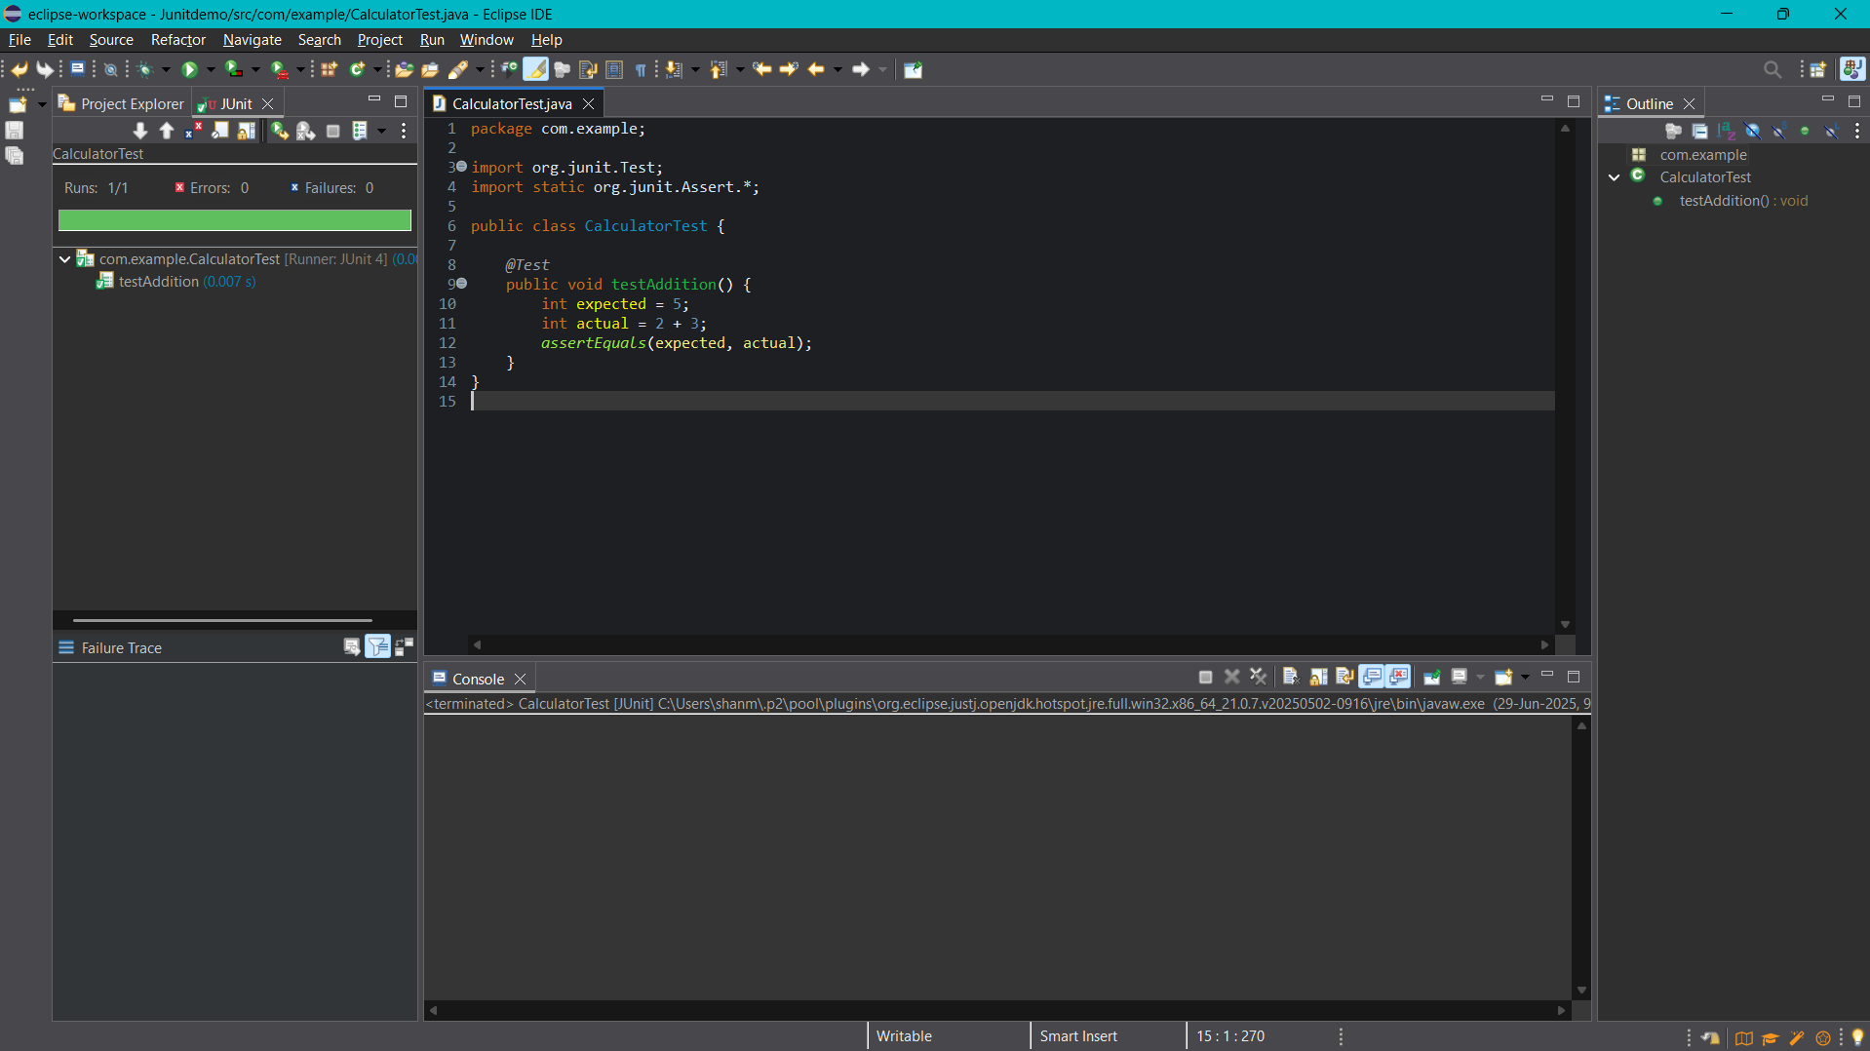

**Exercise 3: Assertions in JUnit**

package com.example;

import static org.junit.Assert.*;

import org.junit.Test;

public class AssertionsTest {

@Test

public void testAssertions() {

assertEquals(5, 2 + 3);

assertTrue(5 > 3);

assertFalse(5 < 3);

assertNull(null);

assertNotNull(new Object());

}

}

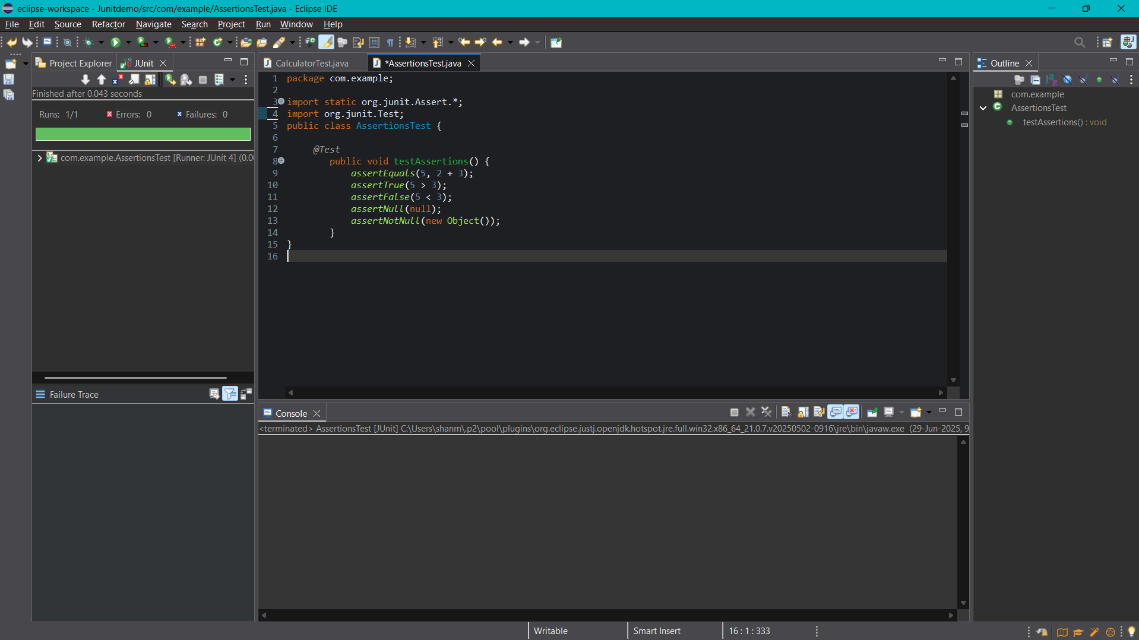

**Exercise 4: Arrange-Act-Assert (AAA) Pattern, Test Fixtures, Setup and Teardown Methods in JUnit**

**Calculator.java**

package com.example;

public class Calculator {

public int add(int a, int b) {

return a + b;

}

public int subtract(int a, int b) {

return a - b;

}

}

**CalculatorTest1.java**

package com.example;

import org.junit.Before;

import org.junit.After;

import org.junit.Test;

import static org.junit.Assert.*;

public class CalculatorTest1 {

private Calculator calculator;

@Before

public void setUp() {

calculator = new Calculator();

System.out.println("Setup complete");

}

@After

public void tearDown() {

calculator = null;

System.out.println("Teardown complete");

}

@Test

public void testAddition() {

int result = calculator.add(2, 3);

assertEquals(5, result);

}

@Test

public void testSubtraction() {

int result = calculator.subtract(7, 2);

assertEquals(5, result);

}

}

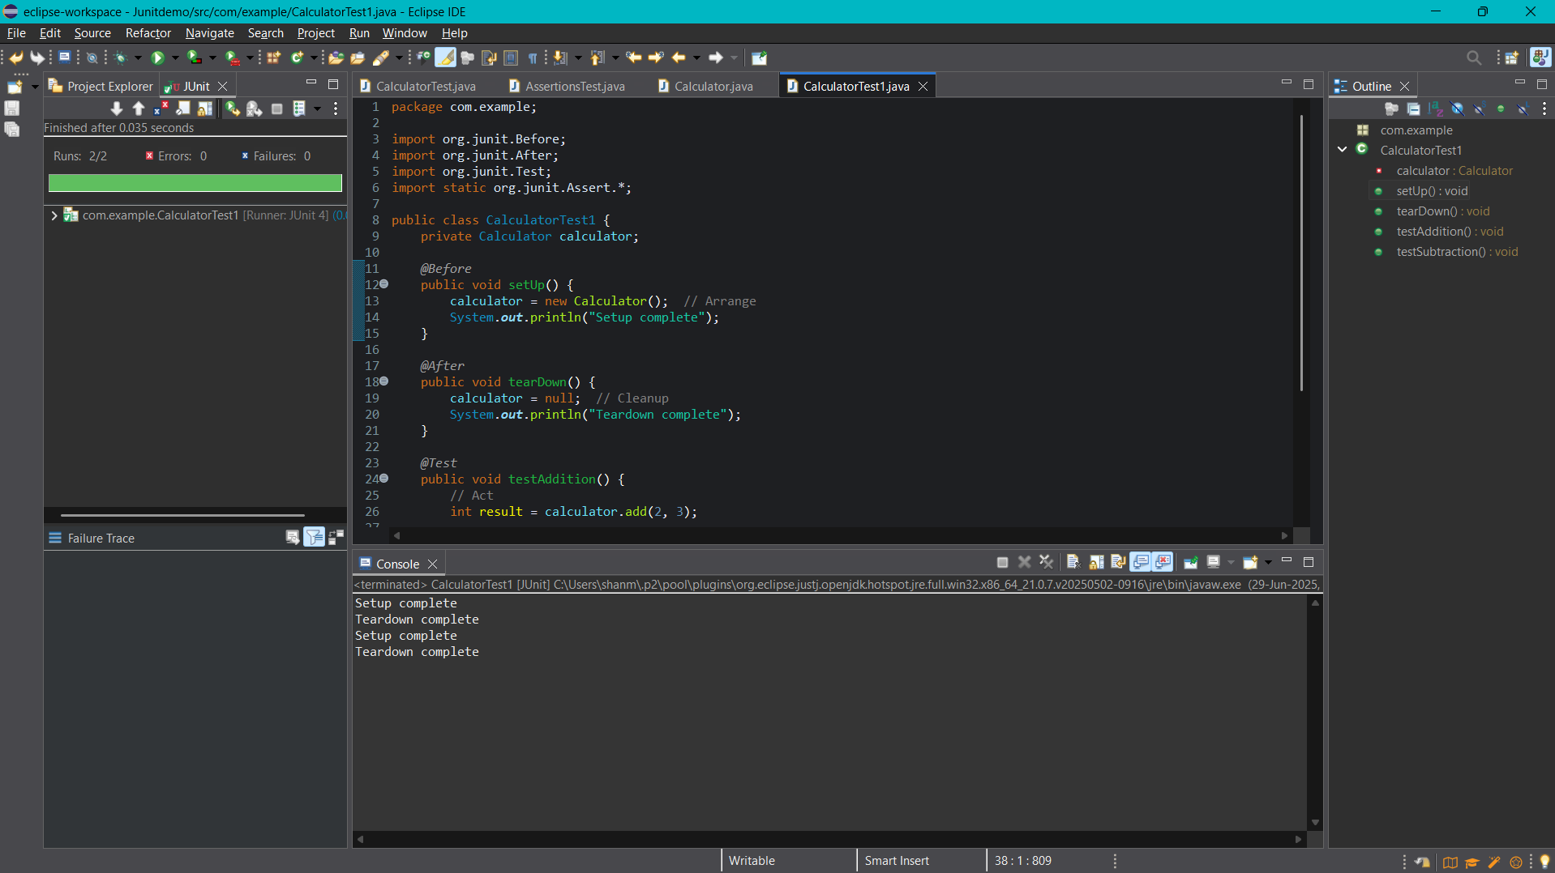

**Additional**

**Exercise 2: Writing Basic JUnit Tests**

**Calculator1.java**

package com.example;

public class Calculator1 {

public int add(int a, int b) {

return a + b;

}

public int subtract(int a, int b) {

return a - b;

}

public int multiply(int a, int b) {

return a * b;

}

public int divide(int a, int b) {

if (b == 0) {

throw new IllegalArgumentException("Cannot divide by zero");

}

return a / b;

}

}

**Calculator1Test.java**

package com.example;

import org.junit.Test;

import static org.junit.Assert.*;

public class Calculator1Test {

@Test

public void testAdd() {

Calculator1 calc = new Calculator1();

assertEquals(5, calc.add(2, 3));

}

@Test

public void testSubtract() {

Calculator1 calc = new Calculator1();

assertEquals(1, calc.subtract(4, 3));

}

@Test

public void testMultiply() {

Calculator1 calc = new Calculator1();

assertEquals(12, calc.multiply(3, 4));

}

@Test

public void testDivide() {

Calculator1 calc = new Calculator1();

assertEquals(2, calc.divide(10, 5));

}

@Test(expected = IllegalArgumentException.class)

public void testDivideByZero() {

Calculator1 calc = new Calculator1();

calc.divide(5, 0); // Should throw IllegalArgumentException

}

}

